WEST HEMPFIELD TOWNSHIP RESIDENTIAL REFUSE & RECYCLING PROGRAM

The Township's goal is to provide trash and recycling collection at the lowest price possible for those residents who wish to participate in the program. We can achieve that goal if everyone takes responsibility for following the guidelines below. Following these guidelines should prevent or eliminate any problems with the pickup of your trash and recycling.

The following information explains the trash and recycling collection program in detail. We have tried to include as much information as possible in this handout in an effort to answer any questions you may have about our program. If you need additional information, please do not hesitate to contact the Township Office at 717-285-5554.

- PLEASE KEEP THIS INFORMATION FOR FUTURE REFERENCE
- WATCH FOR OUR SEMI-ANNUAL NEWSLETTERS FOR UPDATES & CHANGES or visit our website at www.westhempfield.org

COLLECTION DAYS:
WEDNESDAY for all streets that are west of Prospect Road and all streets that are north of Marietta Avenue (both east & west of Prospect Road). This includes residences on both sides of Marietta Avenue west of Prospect Road, all of Prospect Road as well as all of Locust Grove Road, Wynwood Drive, Central Manor Road, Cedar Chase Drive and Columbia Avenue.

THURSDAY for all streets east of Prospect Road that are south of Marietta Avenue with the above
exceptions. This includes residences on both sides of Marietta Avenue east of Prospect Road.

If you have any questions about which day is your collection day, please call our office.

YOU ARE REQUIRED TO PUT TRASH & RECYCLING CURBSIDE (no more than 5 feet from curb) ON THE EVENING BEFORE YOUR SCHEDULED COLLECTION. The Township cannot be responsible for trash that is not out in time. Items that are not out in time are not considered missed, and no return trips will be made. There is no set time of day when the hauler will be in your neighborhood. The time can vary week to week.

TRASH:
Our trash hauler can provide a 96 gallon trash toter at no cost to you. This toter will hold three 32 gallon size containers allowed with our program. The trucks are equipped with a mechanical lifting device that will lift the toter, dump it and set it back down at the curb. If you want to use this toter and do not have one, please contact the Township office to arrange delivery.

Use of the hauler provided toters are strongly encouraged for safety purposes. If you decide you do not want to use it, you can place up to three 32 gallon size cans or bags at the curb each week. If you choose to use the toter, it will be important that you bag all of your trash before placing it inside the toter. DO NOT place loose trash in the toter. The diagram below shows how the toter should be placed at the roadside.
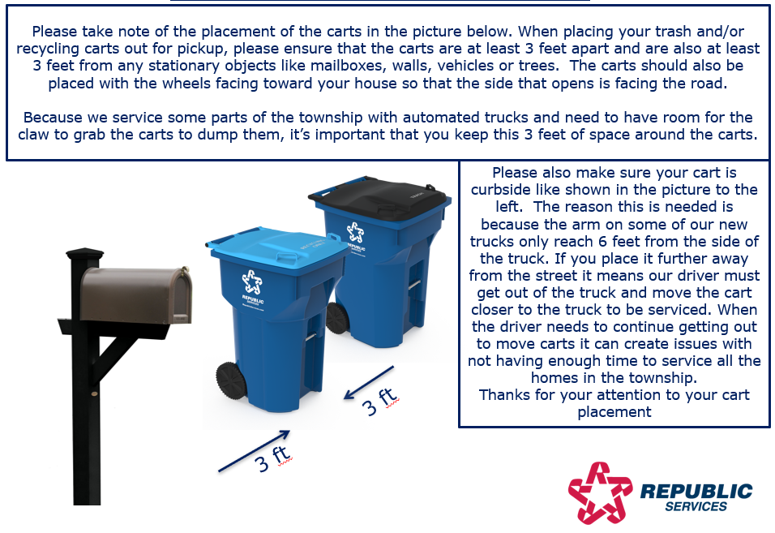

Any trash that does not fit in the large toter, with the lid closed, will be considered “over the limit.” You will have to attach a YELLOW extra service tag to any trash placed outside the toter. If you use 32 gallon containers, any containers over the 3 permitted containers must be tagged with a YELLOW extra service tag available for $2.00 each. (See below for more information.) No loose trash should be placed for pickup; all trash must be contained in some manner.

Please DO NOT place bags beyond the top edge of the toter or trash cans or on top of the closed lid of the toter. Those bags would put you “over the limit” but also could fall off when the toter is lifted and would not be emptied into the truck. Cans should not be filled to overflowing, and bags must be closed securely. If the lid cannot be placed firmly on the can, it is considered over the limit, meaning you should not stack additional bags on top of an already full can. If you have problems with animals getting in the trash, we suggest using cans rather than bags.
ABSOLUTELY NO BURNING OF TRASH ALLOWED.

EXTRA SERVICE TAGS:
Tags can be purchased at the Township office at 3476 Marietta Avenue or ordered by mail. If ordering large quantities by mail, please include postage. Tags cannot be sold to accounts that are past due.

MISSED TRASH:
Trash, recycling or yard waste not picked up on the scheduled day must be left curbside, then call the Township office as soon as possible, either the afternoon of your pickup day or the next business morning. If the hauler has not reported a problem to us, they will return to retrieve the missed items. If the hauler does not return within 24 hours, you should leave the items curbside and let us know it was not picked up. It is important that you contact us each time you have any problem with your service. The Township cannot be held responsible if we are not notified of service problems.

NEW FEATURE ON WEBSITE: Now available from the westhempfield.org website, report your missed trash, recycling, or yard waste directly from the Township website. Visit westhempfield.org and click on the light blue button for “Report Missed Trash/Recycle”. The form requires your contact information and you will need to check the appropriate box for the missed item. This is then reported directly to our hauler and can be used any time of day!

OVERSIZED ITEMS:
Items weighing more than 30 pounds or that are over 4 feet in any dimension must be marked with a RED
extra service tag available for $5.00 each. TWO RED TAGGED ITEMS WILL BE ALLOWED EACH WEEK. The regular trash truck will not take these items, but they should be placed with regular trash. The hauler will send a different truck for these items.

Red tagged items include, but are not limited to, wood or upholstered furniture, mattresses, box springs, microwaves, bicycles, grills (with gas tank removed) push lawn mowers with gas and oil drained. Carpet and padding must be cut into lengths no more than 6 feet then rolled into a bundle and tied securely. Each bundle of carpet or padding would need a red tag attached. These items are limited to a weight that can be easily lifted by two people.

BILLING:
Bills are issued quarterly in January, April, July, and October each year. For 2024, the cost will be $72.50 per quarter. Bills are due upon receipt and any payments not received in our office before the date listed on the bill will be considered past due and will incur a penalty as indicated on each bill. Bills are payable to the Township by cash, check or money order or credit card (bank convenience fee is added for credit card transactions).

An annual discounted rate as indicated at the bottom of the January 1st bill can be paid. Your payment must be received at the Township office BEFORE March 1st to be eligible for this discount. The discounted rate for 2024, is $285.00, if you had a zero balance as of 12/31/23.
PAST DUE ACCOUNTS ARE SUBJECT TO THE DISCONTINUATION OF COLLECTION.

HOLIDAYS:
Collection will be postponed by one day for New Year’s Day, Memorial Day, Independence Day, Labor Day and Christmas. In this occurrence, Wednesday customers will be picked up on Thursday and Thursday customers will be picked up on Friday. In 2024, for Independence Day and Thanksgiving, Wednesday customers will have regular pickup; Thursday customers will have one day delay to Friday. Again, please put trash and recycling out the evening before collection. Any holidays not listed have no effect on the pick-up schedule.

Holidays that affect trash pickup can change each year. Watch for our semi-annual newsletters for these changes. If in doubt, check our website or call the Township Office.

If you do not have your trash out at the appropriate time during a holiday schedule, it will not be considered missed. You will have to attach extra service tags to any extra trash you have the following week. Also, if you have any extra trash due to any holiday activities, especially Christmas, all trash over the amount allowed must be tagged with extra service tags.

YARD WASTE:
To dispose of grass clippings, summertime leaves and green plants through our refuse program, you must place these items in Kraft biodegradable bags available for purchase at most home improvement stores. All bags must have a green yard waste sticker on them, which can be purchased at the Township office for $1.50 each. The kraft bag yard waste will be collected from April through the first week of December. Small twigs, small branches and shrubbery trimmings must also be placed in these bags. If you have yard debris at other times of the year, it will be handled as regular trash. All yard waste will be collected on the same day as your regular trash and recycling.

Brush, larger branches (up to 6" diameter) and any woody material too large for the Kraft bags must be tied into 4 foot bundles no heavier than 30 pounds each and tagged with a GREEN yard waste tag available for purchase from the Township for $1.50 each. Piles of loose clippings, loose limbs, or loose branches will not be taken.

If you remove entire shrubs or bushes, each individual shrub will need a green tag attached to it. Please remove the dirt from the root ball before placing these items for pickup. Each item must weigh less than 30 pounds and be no more than 4 feet tall. If an item is bigger than 4 feet, you will have to cut it into lengths of 4 feet or smaller.

DIRT, stone and rocks are not considered trash or yard waste and will not be taken. If you have sod to dispose of, please let it dry, then remove the dirt from the root section before placing it in the Kraft bags.

An alternate drop off site for yard waste is available for Township residents on Norwood Road near our Township maintenance building. West Hempfield Township has received a grant from the Pennsylvania Department of Environmental Protection (DEP) to make upgrades to our Woody Waste Facility. These upgrades include an automated gate, card access system, and security cameras. Woody Waste Access Cards can be purchased at the Township Building.
ABSOLUTELY NO BURNING OF YARD WASTE MATERIAL ALLOWED.

LEAF COLLECTION:
Each fall, the Township collects leaves which are raked to the curbside by residents. Curbside leaf collection runs from mid-October to the first week in December. Please check our fall newsletter or our website for specific collection dates for your area and instructions concerning this pickup.
NO BURNING OF LEAVES IS PERMITTED.

RESIDENTIAL CORRUGATED CARDBOARD:
A receptacle is available at the rear parking lot of the Township building to drop off corrugated cardboard for recycling and is available 24 hours per day. All boxes must be flattened before placing in the dumpster. DO NOT include any items that are not corrugated. No pizza boxes, cereal boxes or other food product boxes, and no plastic-coated boxes should be disposed of in this dumpster. Absolutely no other material such as newspapers, phone books or plastics should be placed in this dumpster. If in doubt, please check with the Township Office before placing in the dumpster. Be sure to use the proper dumpster and follow instructions posted next to the dumpster. Also, if the dumpster is missing, then it is being taken to Lancaster County Solid Waste Authority to be emptied and will be returned when emptied.

To dispose of cardboard as part of the recycling program – it must be flattened & bundled with bundle no bigger than a pizza box. Place the small bundle in your green recycling bin.

RECYCLING:
At this time, the Township program requires that you recycle corrugated cardboard, plastic bottles and jugs with necks, metal food and beverage cans, and glass jars and bottles.

Please see complete information about requirements for preparing these items on the recycling guide, which can be found on our website. Please do not put any trash in the recycle container. The recycling container does not have to be placed out each week -- only when it is full. Never use plastic bags for recycling materials. Remember to crush all plastic to save room in the bin. ABSOLUTELY NO BURNING OF RECYCLABLE MATERIALS ALLOWED.

Please do not litter. It is against the law and is a nuisance to your neighborhood. To avoid spilled items from your recycling bin, please do not overfill the bin. Remember it is your responsibility to clean up any recycling material that may fall from your bin when it has spilled or has blown about on windy days.

ADDITIONAL RECYCLING OPPORTUNITIES:
Electronic Waste: Desktop Computers, Laptops, Monitors, Computer Keyboards, Computer Mouse, Computer Printers, Computer Speakers, Televisions, Tablets and eReaders must be taken to the Lancaster County Solid Waste Authority, Household Hazardous Waste Facility, 1299 Harrisburg Pike, Lancaster, and is free of charge to County residents. Limit of 10 e-waste items per customer, per day.

Since January 2013, all Televisions of all sizes MUST be taken to this facility for recycling and is free of charge.

Fluorescent light bulbs (including cork screw type bulbs) & ballasts must also be taken to this facility. Up to 30 bulbs per month per household will be accepted free of charge. DO NOT place these items in your regular trash. Call 717-397-9968 for hours of operation or for more information regarding these opportunities.

The following items are also accepted at the HHW facility for free: Cameras, cell phones, smart phones, cell phone chargers & batteries, Bluetooth earpieces, DVD and VCR players, MP3 players, iPods, PDAs, portable electronic game players and video game consoles, stereos and components (CD players, turntables, amplifiers & speakers – but no wooden materials). Limit of 10 e-waste items per customer, per day.

BUSINESS ELECTRONIC WASTE IS NOT ACCEPTED AT THE LCSWMA FACILITY.
TIRES & LARGE HOUSEHOLD APPLIANCES:
Tires and large appliances are collected in April and October. Watch our newsletters or website for announcements of these dates or call the Township Office. This special pickup includes, but is not limited to, washers, dryers, stoves, refrigerators, freezers, dishwashers, water heaters, air conditioners, dehumidifiers, furnaces, etc.

Each appliance must be marked with a BLUE extra service tag which costs $12.00 each and must be purchased no later than NOON of the Friday before the scheduled pickup.

Rimless tires must have one YELLOW extra service tag attached and tires with rims must have two YELLOW extra service tags attached. If the tire and rim are separated, each piece needs a yellow tag attached.

You must register your name and address with the Township Office for any tires or large appliances placed for collection, especially if you already have the necessary tags. If you purchase yellow tags for tires and/or rims, please let Township staff know you are placing tires out for this special pickup. If your appliance and/or tires are not picked up on the scheduled day, leave the items curbside and call the Township Office after 8 AM on the next business day following the scheduled pickup.

STARTING OR STOPPING SERVICE:
As of July 31, 2021, residential customers are no longer permitted to opt-out of our contracted refuse service. Property owners who had opted out prior to July 31, 2021, are grandfathered. By ordinance, all new residential property owners must use the Township’s contracted refuse service.

SPECIAL WASTES:
Many items used in the home or garden are considered household hazardous waste. This includes, but is not limited to, paints and painting supplies, pool chemicals, pesticides, gasoline, oil, other vehicle fluids, cleansers, etc.

EMPTY paint containers (with lids removed) may be included in your trash. Containers with leftover materials must be disposed of through the Lancaster County Solid Waste Management Authority (LCSWMA), Household Hazardous Waste Facility. Please call the Authority at 717-397-9968 for hours of operation and instructions how to prepare these items for disposal. There is no charge for residential customers for this service.

MEDICAL WASTE can be disposed of in your trash, but be sure all items are properly bagged. No loose items should be placed out for pickup. A special container for disposal of needles and lancets can be obtained from the Lancaster County Solid Waste Authority at 1299 Harrisburg Pike at no cost and can be placed in your trash when it is full. You can also use a small container such as a coffee can or detergent bottle, but be sure it is securely capped and placed in your trash, not in the recycling bin.

ASHES – COAL & FIREPLACE:
Ashes must be placed in plastic bags for disposal. Each bag must be less than 30 pounds and there can be absolutely no heat left in them. If there is any sign of melting of the plastic bag, they will not be taken. Each bag will count as a container of trash and will need yellow tags attached if you go over your three container limit.

CONSTRUCTION WASTE
Construction materials, including, but not limited to, wood, plywood, concrete, bricks, roofing, siding, etc. are not accepted for curbside collection. Contact LCSWMA for disposal options.

CHRISTMAS TREES:
During the month of January each year, trees may be dropped off at no charge at Fairview Park on Fairview Road where they will be turned into mulch for use in Township parks. Remove all decorations and any bags used for transport. Please note this site is different than our summertime drop off site.

To dispose of the tree as trash, it must be tagged with a RED $5.00 extra service tag, clearly visible from the street. DO NOT place the tree in any type of bag. Trees cannot be bigger than 6 feet in any dimension to be disposed of as trash. There is no set date for the pickup of Christmas trees disposed of as trash. However, none will be taken after April 1. It will be considered yard waste after April 1.

